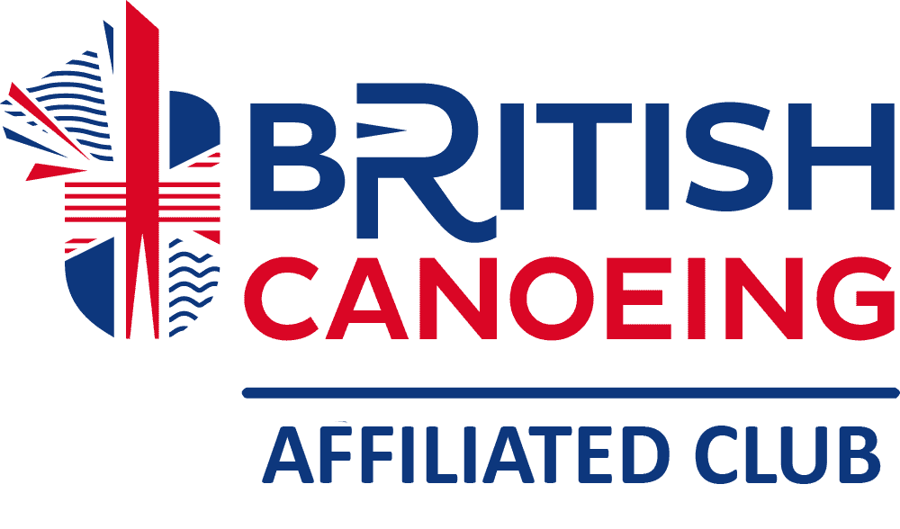

MEMBERSHIP APPLICATION FORM 2024– 2025

Please complete and return a completed form to the pool with card payment, or email form to
Paul Stephenson – paulrstevo@sky.com, and pay by bank transfer.

Surname
First name
Gender | Male |  |  | Female
DOB if under 18
Age category | Under 13 |  |  | 14 - 18 |  |  | 19 - 25 |  |  | 26 - 45 |  |  | 46 +
Address
 | Postcode
Home tel. no.
Mobile No.
e-mail address
e-mail address | @

Your details will only be used for Club business. If you do NOT wish to be added to the club Whatsapp group, tick here.

If you are a new member and over 18 years old, you have to provide proof of your identity. The evidence must contain both your name and address (driving licence or utility bill usually shown.)
If applying for membership in person, original copies will be returned immediately, but if applying by post a photocopy is accepted.

Please indicate the category of membership for which you are applying. The details of these and of the related prices are on the 'membership fees' document in the useful information section of the club website – www.peninsulacanoeclub.org.uk

If you are a members of Canoe England, SCA, WCA or CANI please quote your number
New member
Renewing member
Membership type (please tick) | Individual adult
Membership type (please tick) | Individual youth
Membership type (please tick) | Family
Membership type (please tick) | Youth family
Membership type (please tick) | Honorary
Membership type (please tick) | Associate
Membership type (please tick) | Life
Bank Transfer details: Peninsula Canoe Club.
Sort code: 20-50-36 Account Number: 90702757
Reference: Your full name.

Please provide the names and telephone numbers of 2 people who could be contacted in an emergency. These will not be published anywhere. Preferably there should be 2 different telephone numbers.

Name contact 1
Relationship
Telephone no.
Name contact 2
Relationship
Telephone no.

The following details would help us to provide the best experience for you within the club. Please tick and fill in as appropriate.

Can you swim? | no |  | yes |  | If yes, about how far?
Do you hold any coaching qualifications? | no |  | yes |  | If yes, please list:
Do you have any interest in becoming a coach? | no |  | yes
Do you hold DBS clearance? | no |  | yes |  | If yes, from which organisation?
Do you have any diagnosed physical, psychological or psychiatric conditions or suffer from any allergies? | no |  | yes |  | If yes, please provide brief details, including medication that is prescribed. These details will be treated as confidential and will only be disclosed to Coaches as appropriate.

I hereby apply to become a member of Peninsula Canoe Club. In so doing, I agree to abide by the Club Rules.
(The Club rules may be found in the 'useful information' Section of the Club website: www.peninsulacanoeclub.org.uk or can be supplied in paper form upon request.)

Signature: _________________________________ Date: _________

FOR OFFICE USE

MEMBER’S NAME _______________________ MEMBERSHIP NUMBER _______

Membership type | Adult ID  check | Checked by | British canoeing | Paid  £ | Date paid | Received by | Put on database | M’ship card sent | Medical note

PLEASE READ THIS STATEMENT AND SIGN THE DECLARATION ON BOTH COPIES. KEEP ONE COPY AND RETURN THE OTHER COPY WITH YOUR MEMBERSHIP FORM.
Kayaking and Canoeing (which we refer to collectively as “paddlesport”) are “assumed risk” activities. That means that we assume (in the sense of expect) that there will be risks and we assume (in the sense of accept) those risks in what we do.
- Part of the fun and challenge of paddlesport are the risks that it involves. The risks vary from the very small (paddling in a swimming pool) to the very large (running white water where no-one has gone before). There is no paddlesport without an element of risk because we are on water and that is an inherently risky place for us to be because we are land animals.
- The risks are not just those of water, rocks and other boats; we are at risk from natural hazards (like weaver fish) and man-made hazards (like pollution).
- Because we assume risks we seek to manage them and as a result paddlesport has a very good safety record.

What do we expect?
- Each type of water has risks and different levels of risks. Some risks are the same whatever the type of water, such as the risk of drowning. But the chances of any risk actually occurring vary from one type of water to the next. Drowning is more likely on a moving water than in a swimming pool.
- A full list of all the potential risks on each type of water would go on for pages but, as examples, here is a brief and very general guide to the main types of water on which we paddle:-
  - Swimming Pool: there are other people on the water and in close proximity, all learning or practising techniques. There is the risk of injury through collision. There is the risk of injury through getting the techniques wrong.
  - Marine Lake: Again there are other people, but there is more space. The risk of collision remains, with other paddlers and with dinghy sailors and windsurfers. There is the risk of getting too cold in the outdoors and in the water.
  - Placid Waters:: these would be canals and lakes. Again there is the risk of collision with all kinds of water users and also with structures like walls and trees. Canals may have muddy banks and deep mud under the water in which the unwary can get stuck. On wide lakes, the wind and weather start to be a risk and the coldness of the water in layers below the surface becomes a risk.
  - Running Rivers: here the risks from collisions with rocks and trees increase and the flow of water also becomes a risk, carrying a paddler with it, pinning a paddler against a rock or even under water. As the river gets stronger and wilder, the risks increase in severity.
  - The Sea: here the risks from the wind and weather increase. There are tides and tidal streams to bear in mind. The distances involved become greater so the risks of fatigue increase.

What do we accept?
- As all paddlesport is risky, we accept that we will meet with risks when we paddle.
- We accept that not all risks can be foreseen; that one of the risks is the unexpected.
- We accept that to deal with risks we get the right training, we use the right equipment and we plan what we are going to do properly BUT we also accept that even the right training and the right equipment and the proper plans cannot get rid of all risks, they can only make them less likely to occur.
- We accept that sometimes, despite the right training and the right equipment and the proper planning, a risk may become a reality and someone may get hurt and, in an extreme case, may get killed. The longer we paddle and the more we challenge ourselves, the more likely it will be that a risk will become a reality.

Peninsula Canoe Club Policy AS A CLUB PADDLING TOGETHER:-
- We learn the techniques to cope with paddling on different waters from coaches who are accredited with British Canoeing.
- We learn what risks to expect and how to minimise them by undertaking the training for the personal achievement awards of the British Canoeing.
- We use the appropriate equipment for the type of water we intend to paddle on and we do not use that equipment unless we have been taught how to do so properly.
- We undertake trips and expeditions which are within our capabilities under the guidance of properly accredited coaches, instructors and leaders.
- We undertake risk assessments, and prepare proper plans, for those trips and expeditions with the coaches concerned, including preparing and handing in Consent Forms.
- If we do not know what the risks of paddling on any particular type of water may be, we ask the coach in charge of the trip to ensure that the trip is within our level of skill and fitness.

DECLARATION
- I have read this document.
- I understand that paddlesport is an “assumed risk” activity and I understand what that means.
- I understand that if I have any questions about what the risks might be to me or to any child of mine or ward of mine in undertaking paddlesport with Peninsular Canoe Club I can ask any coach in charge of the session in which I or my child or my ward wishes to take part.

Name (please print):
Signature |  | Date:
If the person involved is below 18 years of age the parent or guardian must countersign the form.
Name (please print):
Signature of parent/guardian |  | Date:
PLEASE READ THIS STATEMENT AND SIGN BOTH COPIES. KEEP THIS COPY AND RETURN THE OTHER COPY WITH YOUR MEMBERSHIP APPLICATION

- Kayaking and Canoeing (which we refer to collectively as “paddlesport”) are “assumed risk” activities. That means that we assume (in the sense of expect) that there will be risks and we assume (in the sense of accept) those risks in what we do.
- Part of the fun and challenge of paddlesport are the risks that it involves. The risks vary from the very small (paddling in a swimming pool) to the very large (running white water where no-one has gone before). There is no paddlesport without an element of risk because we are on water and that is an inherently risky place for us to be because we are land animals.
- The risks are not just those of water, rocks and other boats; we are at risk from natural hazards (like weaver fish) and man-made hazards (like pollution).
- Because we assume risks we seek to manage them and as a result paddlesport has a very good safety record.

What do we expect?
- Each type of water has risks and different levels of risks. Some risks are the same whatever the type of water, such as the risk of drowning. But the chances of any risk actually occurring vary from one type of water to the next. Drowning is more likely on a moving water than in a swimming pool.
- A full list of all the potential risks on each type of water would go on for pages but, as examples, here is a brief and very general guide to the main types of water on which we paddle:-
  - Swimming Pool: there are other people on the water and in close proximity, all learning or practising techniques. There is the risk of injury through collision. There is the risk of injury through getting the techniques wrong.
  - Marine Lake: Again there are other people, but there is more space. The risk of collision remains, with other paddlers and with dinghy sailors and windsurfers. There is the risk of getting too cold in the outdoors and in the water.
  - Placid Waters: these would be canals and lakes. Again there is the risk of collision with all kinds of water users and also with structures like walls and trees. Canals may have muddy banks and deep mud under the water in which the unwary can get stuck. On wide lakes, the wind and weather start to be a risk and the coldness of the water in layers below the surface becomes a risk.
  - Running Rivers: here the risks from collisions with rocks and trees increase and the flow of water also becomes a risk, carrying a paddler with it, pinning a paddler against a rock or even under water. As the river gets stronger and wilder, the risks increase in severity.
  - The Sea: here the risks from the wind and weather increase. There are tides and tidal streams to bear in mind. The distances involved become greater so the risks of fatigue increase.

What do we accept?
- As all paddlesport is risky, we accept that we will meet with risks when we paddle.
- We accept that not all risks can be foreseen; that one of the risks is the unexpected.
- We accept that to deal with risks we get the right training, we use the right equipment and we plan what we are going to do properly BUT we also accept that even the right training and the right equipment and the proper plans cannot get rid of all risks, they can only make them less likely to occur.
- We accept that sometimes, despite the right training and the right equipment and the proper planning, a risk may become a reality and someone may get hurt and, in an extreme case, may get killed. The longer we paddle and the more we challenge ourselves, the more likely it will be that a risk will become a reality.

Peninsula Canoe Club Policy AS A CLUB PADDLING TOGETHER:-
- We learn the techniques to cope with paddling on different waters from coaches who are accredited with British Canoeing.
- We learn what risks to expect and how to minimise them by undertaking the training for the personal achievement awards of the British Canoeing.
- We use the appropriate equipment for the type of water we intend to paddle on and we do not use that equipment unless we have been taught how to do so properly.
- We undertake trips and expeditions which are within our capabilities under the guidance of properly accredited coaches, instructors and leaders.
- We undertake risk assessments, and prepare proper plans, for those trips and expeditions with the coaches concerned, including preparing and handing in Consent Forms.
- If we do not know what the risks of paddling on any particular type of water may be, we ask the coach in charge of the trip to ensure that the trip is within our level of skill and fitness.

DECLARATION
- I have read this document.
- I understand that paddlesport is an “assumed risk” activity and I understand what that means.
- I understand that if I have any questions about what the risks might be to me or to any child of mine or ward of mine in undertaking paddlesport with Peninsular Canoe Club I can ask any coach in charge of the session in which I or my child or my ward wishes to take part.

Name (please print):
Signature |  | Date:
If the person involved is below 18 years of age the parent or guardian must countersign the form.
Name (please print):
Signature of parent/guardian |  | Date:

